

**National Textile University, Faisalabad**

|  |  |
| --- | --- |
| Lab Manual | |
| Name: | Muhammad Ibrahim |
| Class: | SE-4-B |
| Reg#: | 23-NTU-CS-1177 |
| Subject: | SCD |
| Submitted to: | Ma’am Kalsoom |
| Date: | 06/02/2025 |

***Lab-01) Basic Object Oriented Programming***

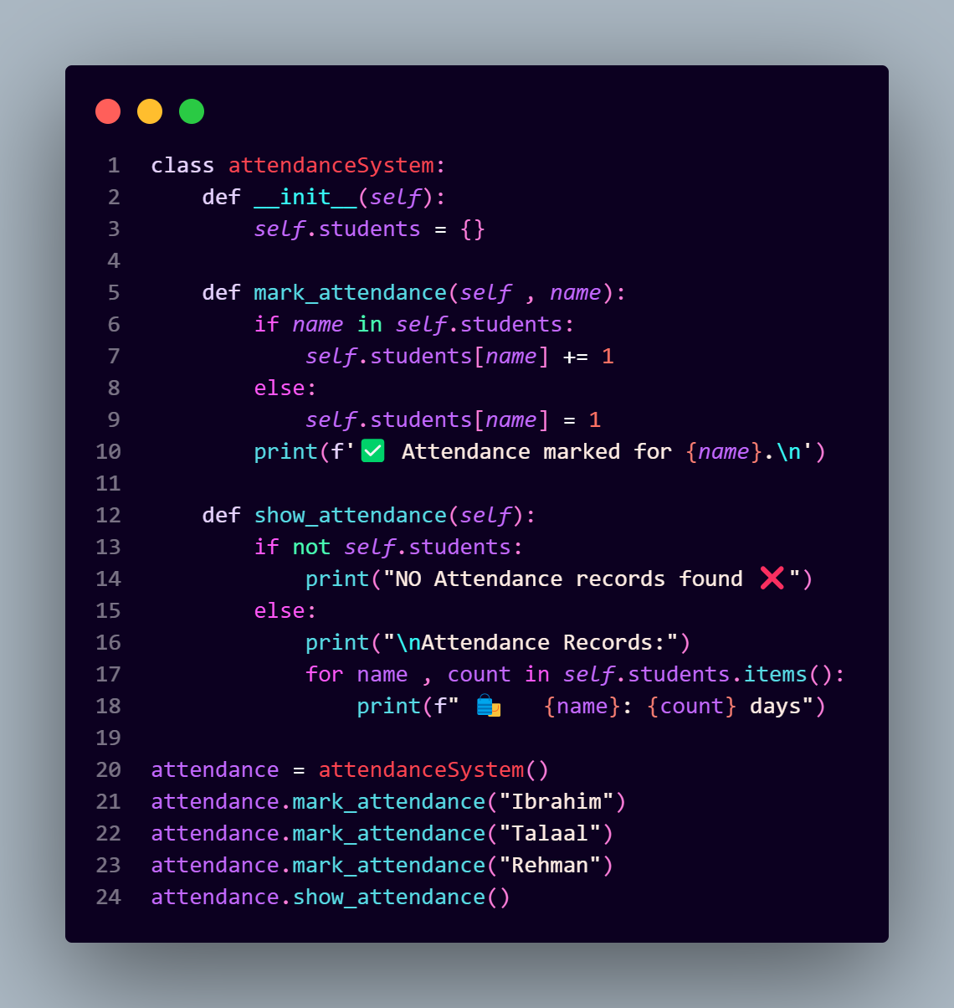

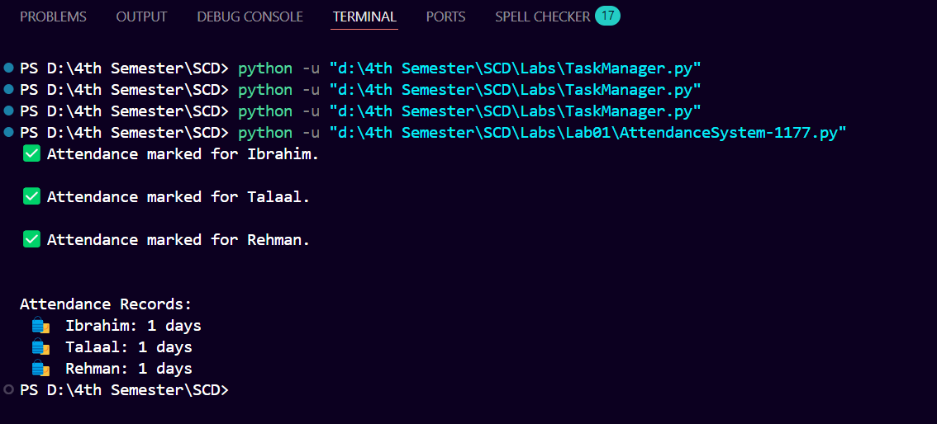

***Lab-02) Attendance Management System***

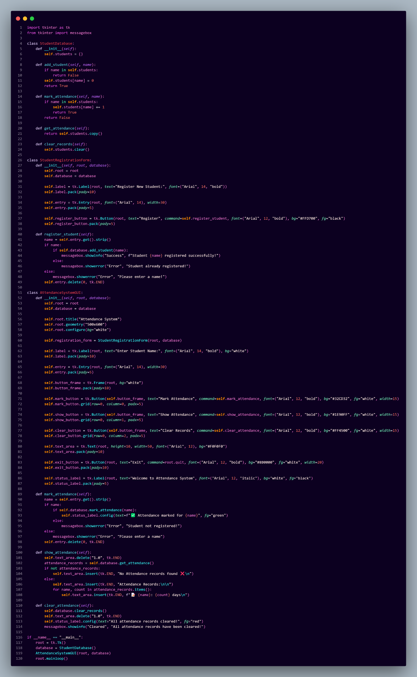

***Output:***

